**<https://github.com/marsja/jupyter/blob/master/Python_ANOVA/One_Way_Python_ANOVA.ipynb>**

**SE CALCULA POR 3 FORMAS**

**LUEGO SE COMPARA EN PARES <- IMPORTANTE**

import pandas as pd

datafile = 'https://vincentarelbundock.github.io/Rdatasets/csv/datasets/PlantGrowth.csv'

df = pd.read_csv(datafile)

df.head()

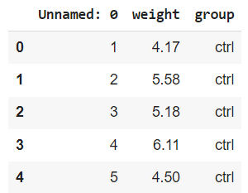

#Explore, create a boxplot

df.boxplot('weight', by='group', figsize=(12, 8))

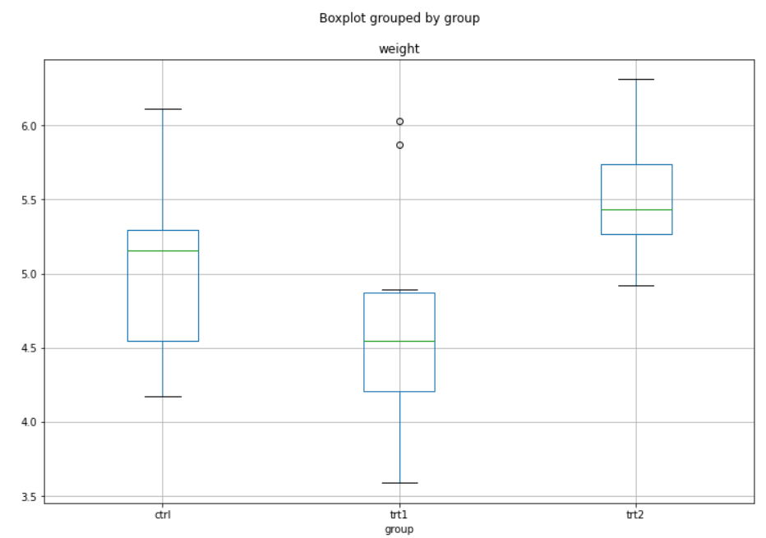

**Group: ctrl, trt1, trt2**

**Weight: 3.5 - 6**

ctrl = df['weight'][df.group == 'ctrl']

grps = pd.unique(df.group.values)

d_data = {grp:df['weight'][df.group == grp] for grp in grps}

### Anova usig Scipy

**from** scipy **import** stats

# Son 3 grupos de datos

F, p **=** stats**.**f_oneway(d_data['ctrl'],

d_data['trt1'],

d_data['trt2'])

print(F, p)

4.84608786 0.01590995

**Como 0.01 < 0.05 hay significancia que las medias sin similares**

**OTRA OPCION DE CALCULO**

### Degrees of Fredoom

k = len(pd.unique(df.group))   # 3 number of conditions (3 groups)?

N = len(df.values)   # 10 conditions times participants

n = df.groupby('group').size()[0] # 30 Participants in each condition

DFbetween **=** k **-** 1

DFwithin **=** N **-** k

DFtotal **=** N **–** 1

### Sum of Squares Between, WIthin, and Total

# Between

SSbetween = (sum(df.groupby('group').sum()['weight']**2)/n) \

    - (df['weight'].sum()**2)/N

# Within

sum_y_squared = sum([value**2 for value in df['weight'].values])

SSwithin = sum_y_squared - sum(df.groupby('group').sum()['weight']**2)/n

# Total

SStotal = sum_y_squared - (df['weight'].sum()**2)/N

### Means Square Errors and F-value

MSbetween = SSbetween/DFbetween

MSwithin = SSwithin/DFwithin

F = MSbetween/MSwithin

p = stats.f.sf(F, DFbetween, DFwithin)

print(F, p)

4.8460878 0.015909958

**Da nuevamente los mismos valores**

**Como 0.01 < 0.05 hay significancia que las medias sin similares**

### Calculate Effect sizes: Eta Squared and Omega Squared:

eta_sqrd = SSbetween/SStotal

om_sqrd = (SSbetween - (DFbetween * MSwithin))/(SStotal + MSwithin)

results = {'sum_sq':[SSbetween, SSwithin],

           'df':[DFbetween, DFwithin],

           'F':[F, ''],

            'PR(>F)':[p, ''],

          'EtaSq':[eta_sqrd, ''],

          'OmegaSq':[om_sqrd, '']}

aov_table1 = pd.DataFrame(results,

                          index=['Group', 'Residual'])

aov_table1

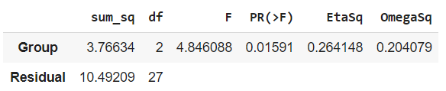

**Otra forma de calcularlo**

import statsmodels.api as sm

from statsmodels.formula.api import ols

mod = ols('weight ~ group',

                data=df).fit()

aov_table = sm.stats.anova_lm(mod, typ=2)

print(aov_table)

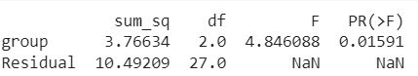

**Tercera forma de calcular**

esq_sm = aov_table['sum_sq'][0]/(aov_table['sum_sq'][0] + aov_table['sum_sq'][1])

aov_table['EtaSq'] = [esq_sm, 'NaN']

print(aov_table)

## Pairwise Comparisons

pair_t = mod.t_test_pairwise('group')

pair_t.result_frame

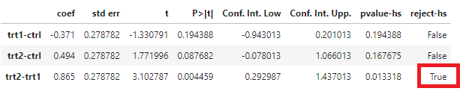

**En los 3 grupos no se rechaza, pero si se compara trt2 – trt1 si se ve diferencia**

